Question 1:
The augmented matrix is equivalent to [1, x, x², y] for each point
The augmented matrix for the points is: [[1, -1, 1, 3], [1, 1, 1, -5], [1, 2, 4, 2], [1, 3, 9, -2]]
The matrix in reduced row echelon form is: [[1, 0, 0], [0, 1, 0], [0, 0, 1], [0, 0, 0]]
This system has no solutions and therefore is inconsistent. It is also not linearly independent.

Question 2:
The augmented matrix is equivalent to [1, x, x², x³, y] for each point
The augmented matrix for the points is:
[[1, -1, 1, -1, 3], [1, 1, 1, 1, -5], [1, 2, 4, 8, 2], [1, 3, 9, 27, -2]]
The matrix in reduced row echelon form is:
[[1, 0, 0, 0, -37/4], [0, 1, 0, 0, -41/24], [0, 0, 1, 0, 33/4], [0, 0, 0, 1, -55/24]]
This system is linearly independent:
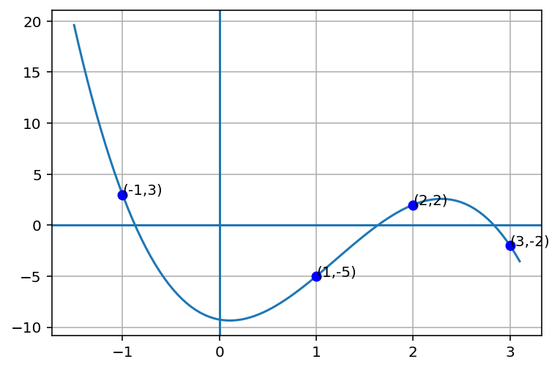

Question 3:
The augmented matrix is equivalent to [1, x, x², x³, x⁴, y] for each point
The augmented matrix for the points is:
[[1, -1, 1, -1, 1, 3], [1, 1, 1, 1, 1, -5], [1, 2, 4, 8, 16, 2], [1, 3, 9, 27, 81, -2]]
The matrix in reduced row echelon form is:
[[1, 0, 0, 0, 6, -37/4], [0, 1, 0, 0, -5, -41/24], [0, 0, 1, 0, -5, 33/4], [0, 0, 0, 1, 5, -55/24]]
This system is not linearly independent:


3.1:
f(0) = 0 would be possible if it were added as a point.
The equation would change to: f(x) = bx + cx² + dx³ + ex⁴
The augmented matrix for the points is:
[1, -1, 1, -1, 1, 3], [1, 1, 1, 1, 1, -5], [1, 2, 4, 8, 16, 2], [1, 3, 9, 27, 81, -2], [1, 0, 0, 0, 0, 0]]
The matrix in reduced row echelon form is:
[[1, 0, 0, 0, 0, 0], [0, 1, 0, 0, 0, -113/12], [0, 0, 1, 0, 0, 13/24], [0, 0, 0, 1, 0, 65/12], [0, 0, 0, 0, 1, -37/24]]
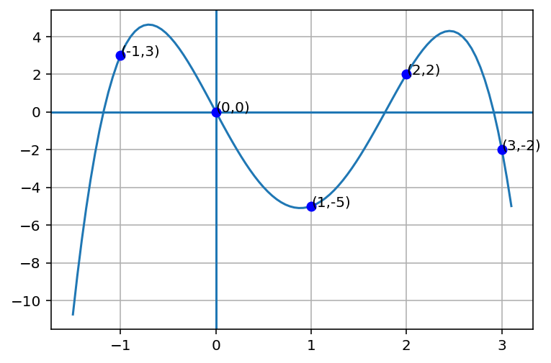

3.2
The set does not have a horizontal tangent at (-1,5) since f′ (1) = b + 2c + 3d + 4e = 0 is not true

